Sprouted Group of Companies
The Sprouted Group of Companies is an integrated Ghanaian agribusiness that links smallholder farmers to finished consumer products across two of the country's most important crops: cashew and cocoa. The Group comprises three registered entities, each with a distinct mandate, operating as a single value chain from farm to market.
Entity | Core business | Primary crop | Role in the Group
Sprouted Roots Limited | Farmer impact programs and sustainable sourcing | Cashew and cocoa | Secures raw material supply and farmer livelihoods
Sprouted Crafts Limited | Cashew sourcing, processing and value-added products | Cashew | Adds value through processing and product diversification
Oikazi Limited | Cocoa processing into premium consumer products | Cocoa | Converts Ghana's cocoa into branded finished goods

The Group exists to prove that value addition can happen at origin. Rather than exporting raw commodities, Sprouted processes, packages and brands at home, retaining more value in Ghana while giving farmers a reliable, structured market for their harvest.
Sprouted Crafts Limited
Sprouted Crafts sources raw cashew nuts and processes them to the specifications of its partners, with a clear path toward its own branded, value-added cashew products.
Operations
- Sourcing raw cashew nuts directly from farming communities, supported by Sprouted Roots.
- Processing raw cashew to meet the quality, grade and volume requirements of partner buyers.
- Reliable, traceable supply that partners can build their own production around.
Growth direction
Sprouted Crafts intends to move up the value chain from raw material supply into finished goods for local and international markets, including packaged roasted and flavoured cashew nuts, cashew butter and spreads, and other cashew-based derivatives such as snacks and ingredients.
This shift captures margin that currently leaves Ghana with raw exports and positions Sprouted Crafts as a consumer brand rather than a commodity supplier.
Sprouted Roots Limited
Sprouted Roots is the Group's impact and sourcing foundation. It designs and delivers programs that raise farmer productivity and incomes, and in doing so guarantees Sprouted Crafts and Oikazi a dependable supply of quality cashew and cocoa.

Program areas
- Farmer training: good agricultural practices, post-harvest handling, quality standards and farm business skills.
- Supply chain support: aggregation, transparent pricing, logistics and quality control between farm gate and factory.
- Livelihood initiatives: interventions that strengthen household income and resilience in the agricultural communities the Group sources from
Why it matters to the Group
Quality finished products depend on quality raw materials, and quality raw materials depend on motivated, well-equipped farmers. By investing in farmers first, Sprouted Roots turns sourcing from a transactional purchase into a long-term partnership, reducing supply risk for the processing companies and building the traceability and impact credentials that premium local and export buyers increasingly require.
Oikazi Limited
Oikazi processes cocoa beans into premium finished products, drawing on Ghana's standing as one of the world's leading cocoa origins to build a competitive confectionery and cocoa value-addition business.
Product focus
- Chocolate: bars and confectionery made from Ghanaian cocoa.
- Cocoa spreads: cocoa-based spreads for retail and food service.
- Cocoa derivatives: other cocoa-related products such as cocoa powder, nibs and drinking cocoa, developed as the business scales.
Market positioning
Oikazi targets both domestic and export markets. At home, it offers consumers a locally made premium alternative to imported chocolate. Abroad, it competes on origin, traceability and the story of value added in Ghana, supported by the farmer programs run through Sprouted Roots.
How the Group Works Together
The three companies form one value chain: Sprouted Roots secures supply and impact at the farm, Sprouted Crafts and Oikazi add value through processing, and the resulting products reach local and export customers under the Group's brands.
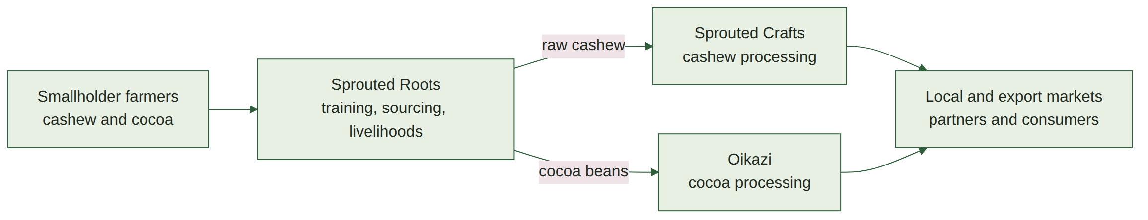
Read left to right: farmers supported by Sprouted Roots deliver raw cashew and cocoa into the two processing companies, which convert them into products for partners and consumers. Value and learning flow back the other way, as market requirements shape the training and quality standards Sprouted Roots delivers on the farm.
Strategic Pillars
The Group's strategy rests on three commitments that run through every entity.
Pillar | What it means in practice | Led by
Sustainable agriculture | Farmer training, fair and transparent sourcing, and programs that improve livelihoods in the communities the Group buys from | Sprouted Roots
Value addition | Processing cashew and cocoa in Ghana into finished, branded products instead of exporting raw commodities | Sprouted Crafts and Oikazi
Market expansion | Building demand in domestic retail while growing export channels for premium, traceable Ghanaian products | All three entities

Together these pillars describe a business that creates measurable impact for farmers, retains value in Ghana, and delivers quality products to consumers at home and abroad.

